**Extra Keywords**

How to configure gmail in thunderbird with pop, thunderbird gmail pop3, thunderbird gmail configuration could not be verified, thunderbird gmail smtp, Thunderbird Gmail - IMAP vs POP3, gmail thunderbird configuration, gmail for thunderbird, gmail thunderbird imap.

**Note: Keywords used in the article are in Bold.**

**Keywords**

**Gmail to Thunderbird**, Gmail to Thunderbird contacts, **import Gmail to Thunderbird**, download Gmail to Thunderbird, gmail to thunderbird download, gmail to thunderbird apps, **how to import gmail to thunderbird**, thunderbird junk filtering, **Mozilla Thunderbird**, gmail to thunderbird converter, gmail to thunderbird transfer, gmail using thunderbird, gmail with thunderbird

**A Comprehensive Guide to Import Gmail to Thunderbird**

With hundreds of email clients on offer, choosing the best one is also a task. The most common one, Gmail is a web based service. An internet connection is always needed to even view the mailbox. However, there are desktop email services more suitable for offline use. Mozilla Thunderbird is one such desktop application that makes it possible to read emails, from multiple IDs without a browser. As you remain logged in, it saves fetch time and offers desktop notifications for whenever a new email is received. In the following sections, we will discuss how to import Gmail to Thunderbird.

**Reasons to Move from Gmail to Thunderbird**

The shift from Gmail to Thunderbird is simple. Thunderbird can be configured with multiple IDs and all emails are visible in a clean interface. It has dedicated filtering to remove junk mail, can categorize into folders and allow sorting. Below are some users who have shared their experience while having shifted from Gmail to Thunderbird:

* “I had been using Gmail for years, but when I used Thunderbird for official purposes, I was very impressed. Now I am able to read and mark mails, even if my internet is not connected.”
* “I installed Thunderbird at the recommendation of a friend and it was the best decision. I don’t worry about junk mail anymore, and all my unread mails are in place. ”

**Method of Importing Gmail to Thunderbird**

The procedure for fully importing Gmail to Thunderbird is a 2 fold process

1. Importing emails through IMAP
2. Importing Contacts through CSV file.

Let’s look at both as follows.

**Steps to Import Emails from Gmail to Thunderbird**

Following are the steps to import emails:

1. Download and install Thunderbird on your computer.
2. Open the Gmail account that you wish to import to Thunderbird.
3. To ensure that your Gmail is equipped to be extracted to another application, open Settings. Click on ***Settings*** >>Settings.
4. Go to ***‘Forwarding and POP/IMAP’***. Under the IMAP Access section, choose ***‘Enable IMAP’***. Before exiting, click on ‘***Save Changes’***.

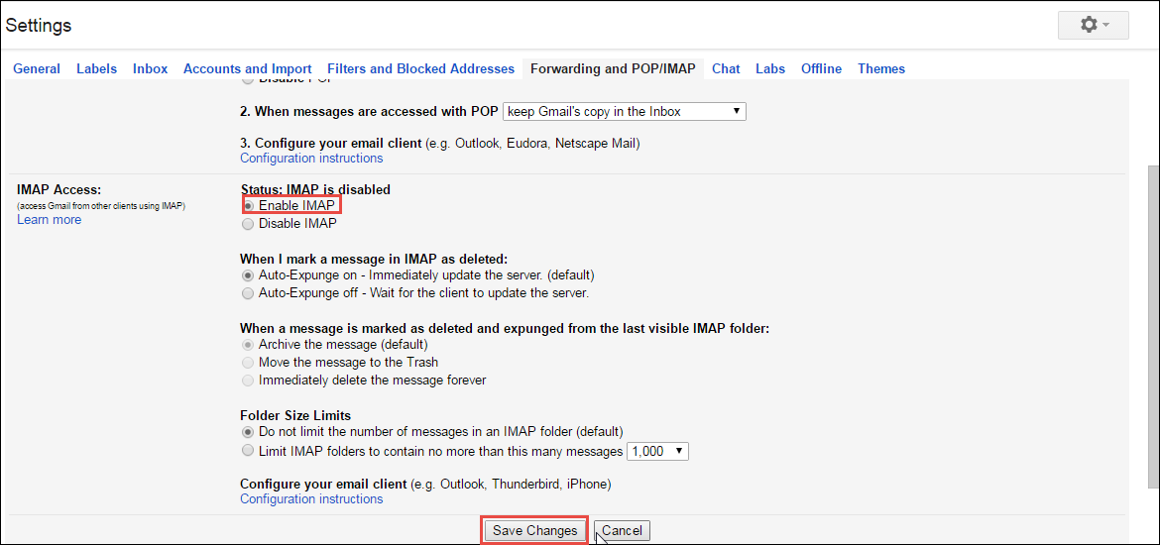

1. Open Thunderbird. Right click on ‘***Local Folders’*** and select ‘***Settings***’.

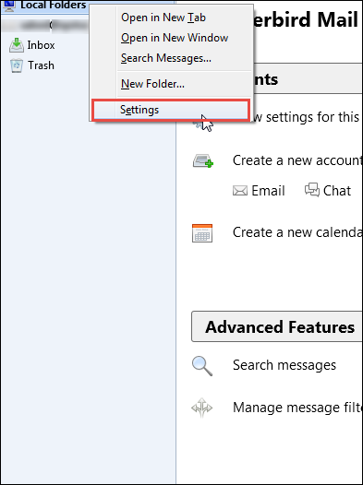

1. A new dialog box opens. Click on ***‘Account Actions’*** on the bottom left, and choose ‘***Add Mail Account’***.

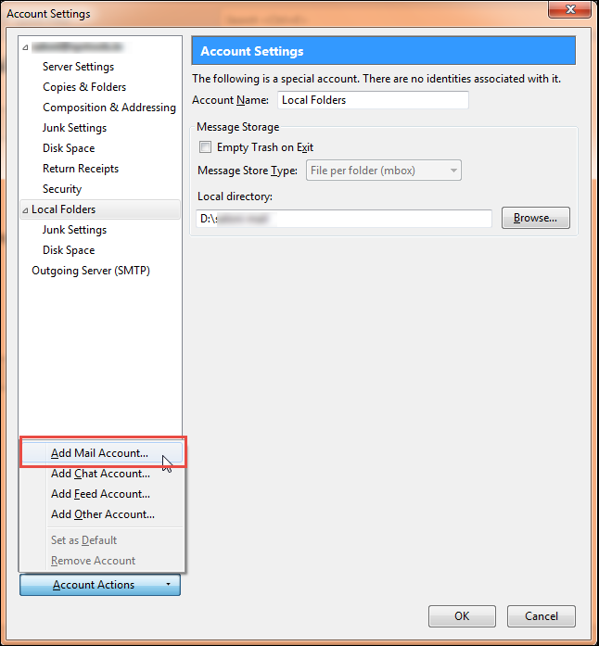

1. Mail Account Setup dialog box pops up. Enter your Name, Email address (to be imported), and the password to that email ID. Click on ‘***Continue***’.

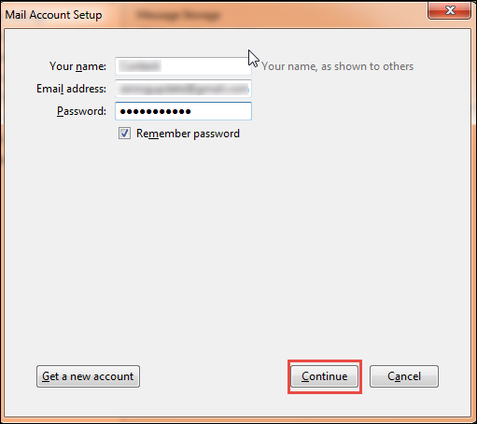

1. Choose the ‘***IMAP(remote folders)***’ radio button and click ‘***Done***’.

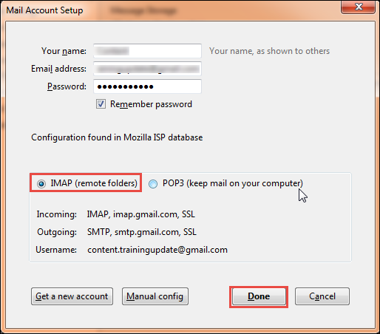

1. The last step is to choose the location of where your mails will be locally stored. Click on ‘***Browse***’ to change the directory. If the location is to your satisfaction, click on ‘***OK***’ to finish setup.

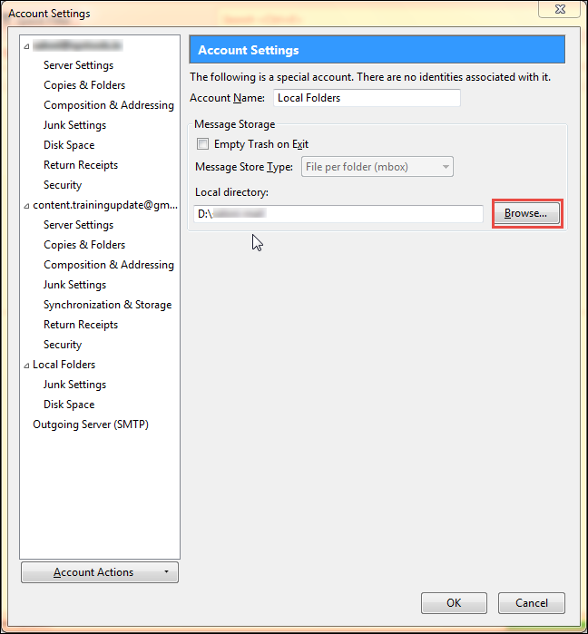

1. The new email ID starts appearing in the left pane. Double click on it, and select ***‘Read Messages’*** to start seeing all your emails in Thunderbird. Now you can Write a new message, change settings and set up advanced features as per your liking.

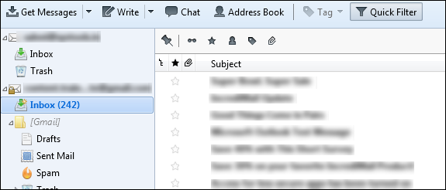

**Steps to Import Contacts from Gmail to Thunderbird**

A separate procedure should be followed to import Google Contacts to Thunderbird.

1. Log in to your Google account. Click on Gmail and select ***Contacts***. Google Contacts open in a new tab.

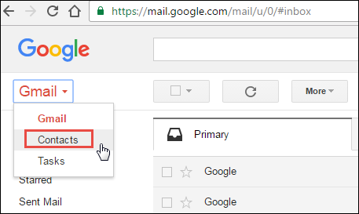

1. Click on ***More*** from the left menu, and click on ***‘Export’***. On some computers, a warning appears that the Export feature is not available in the new preview version of Contacts. In that case, select ‘***Go To Old Contacts’***.

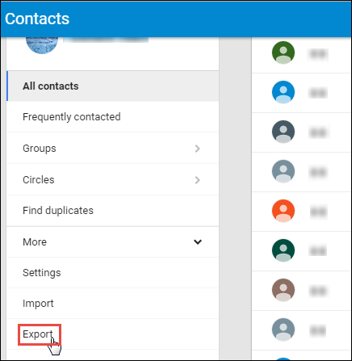

1. Contacts opens up in a new tab. Select the contacts you want to export by marking each of them. Or, select all using the ‘***All***’ option. It will tick mark all contacts.

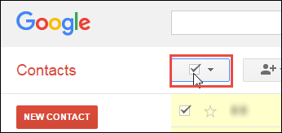

1. Go to More from the top menu and select ‘***Export***’.

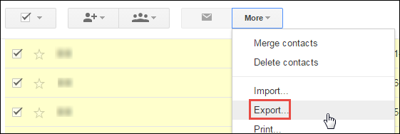

1. A new dialog box opens. Choose ‘***Selected Contacts***’ for the first question, and ‘***Outlook CSV format*** (for importing into Outlook or another application)’ for the second question and click on ‘***Export***’. A CSV file is downloaded to your computer.

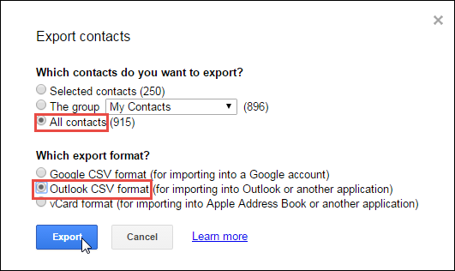

1. Now to import these contacts, open Thunderbird and click on Address Book.

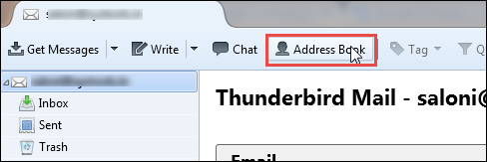

1. Thunderbird Address window opens. Click on ***Tools*** from the top ribbon and select ‘***Import***’.

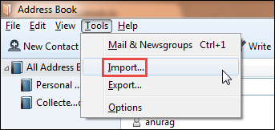

1. Select ***’Address Books’*** from the available options and click on Next.

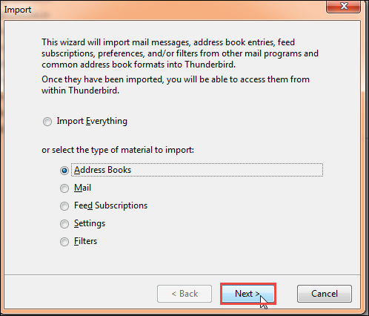

1. In the new box, choose option ‘***Text File (LDIF, .tab, .csv, .txt)***’ and click ‘***Next***’.

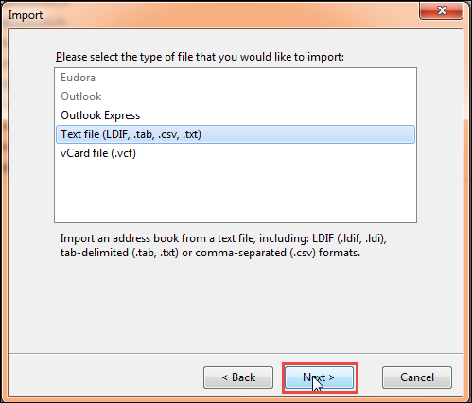

1. In the new Explorer window, browse to the directory where the saved Gmail contacts file is located. Select ‘***All Files’*** to see the .csv and then double click to select it.

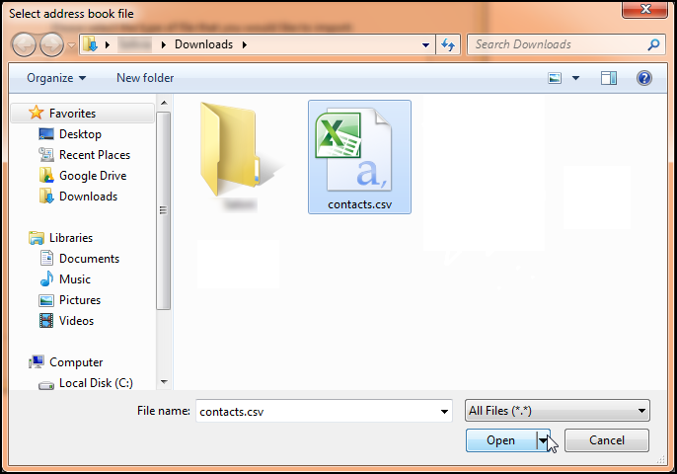

1. In the Import Address Book dialog box, it will allow you to choose which contact attributes you wish to import. You can select as many or all of them and click ‘***OK***’.

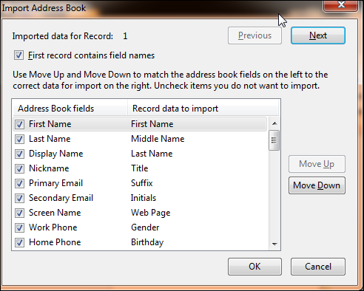

1. Your contacts have now been successfully imported. A new list name showing Contacts appears on the left pane of Thunderbird Address Window.

Gmail is now completely imported to Thunderbird. You can now access your emails offline.

**Conclusion**

This article was a guide to import your Gmail to Thunderbird seamlessly. Thunderbird is steadily rising as the preferred desktop client for many users. The shift can be achieved by importing your emails and contacts one by one and the result is a more robust desktop application with diverse uses.